**COS 214 Project**

**Julianna Venter**

**Ronin**

**Sameet**

**Kea**

**Thapelo**

**Morgan**

**Task 1:**

**Task 2:**

1. **Functional Requirements:**

* Two bannermen arrays must be created
* A user must be able to choose to attack
* If a user doesn’t attack they are forced to yield and lose the war
* If the user attacks they must be able to pick their attacking Bannerman
* If a user attacks they must be able to pick who they are attacking
* A user must be able to choose their attack strategy
* A user will win or lose their war based on a mix of choices and random chance
* A user must be able to choose to send for supplies if their bannerman survives the battle
* A user will win the battle if the enemy bannermen are all dead
* A user will lose the battle if their bannermen are all dead, or they run out of money

1. 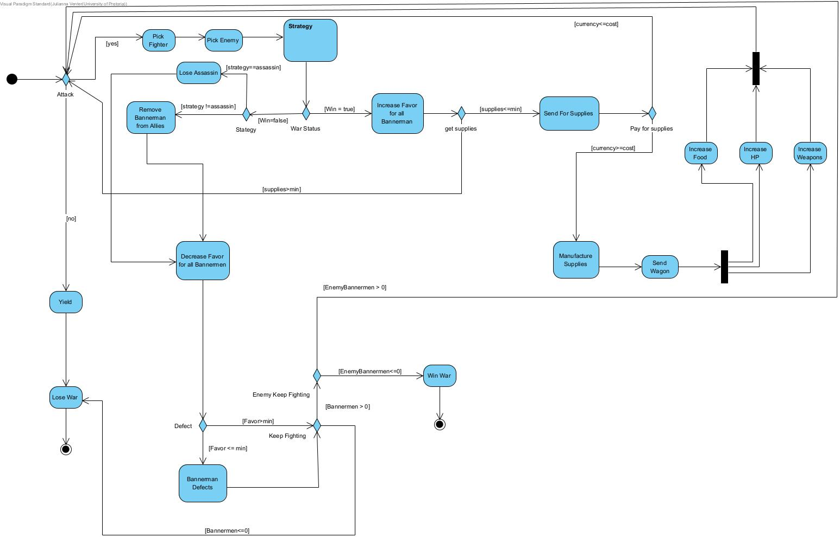

Activity diagram for the main application.

Activity diagram for Strategy methods.

1. In UML
3. 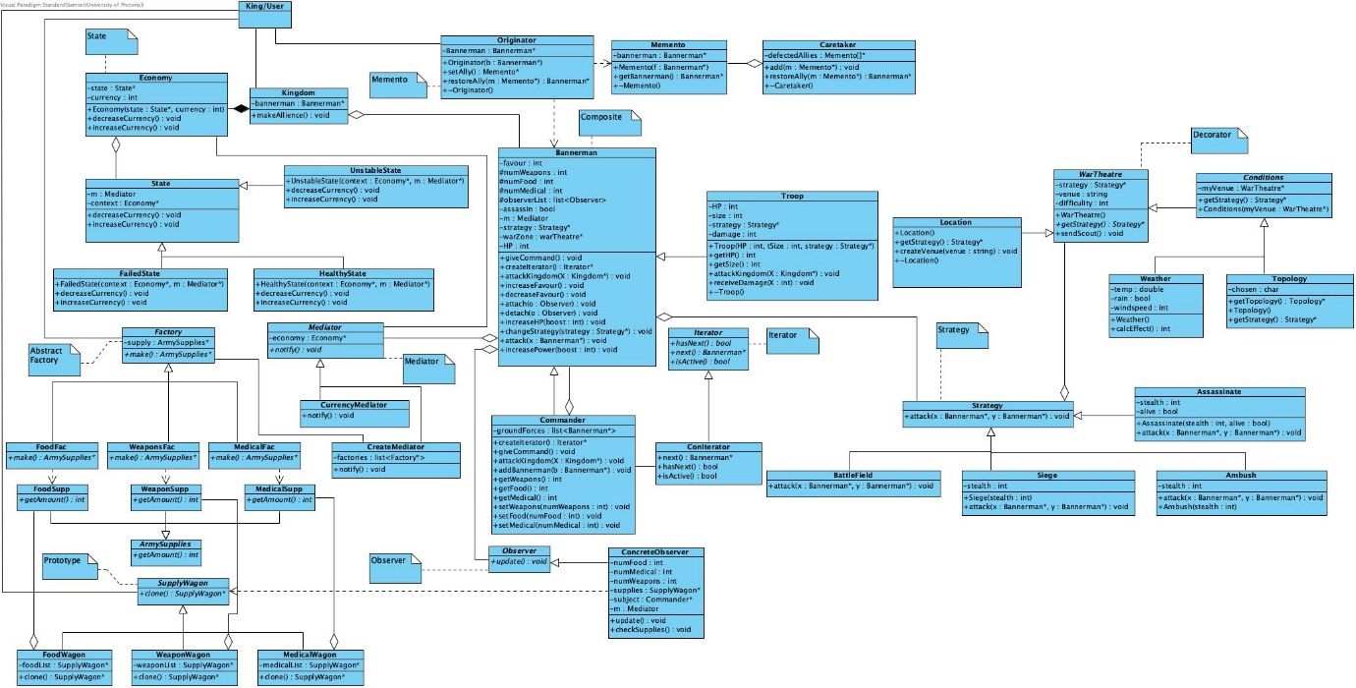**Initial UML v 1**
4. 

